

Design & Technology: Product Design - Specification at a glance

This qualification is linear. Linear means that students will sit all their exams and submit all their non-exam assessment at the end of the course.
Subject content
1. Technical principles
2. Designing and making principles
Assessments
Paper 1
What's assessed
Technical principles
How it's assessed
Written exam: 2 hours and 30 minutes
120 marks
30% of A-level
Questions
Mixture of short answer and extended response.
Paper 2
What's assessed
Designing and making principles
How it's assessed
Written exam: 1 hour and 30 minutes
80 marks
20% of A-level
Questions
Mixture of short answer and extended response questions.
Section A:
Product Analysis: 30 marks
Up to 6 short answer questions based on visual stimulus of product(s).
Section B:
Commercial manufacture: 50 marks
Mixture of short and extended response questions
Non-exam assessment (NEA)
What's assessed
Practical application of technical principles, designing and making principles.
How it's assessed
Substantial design and make project
100 marks
50% of A-level
Evidence
Written or digital design portfolio and photographic evidence of final prototype.

Year 12 Summer Transition Work A Level Design & Technology: Product Design

As part of the course, you need to have a good knowledge of the work of influential designers and how their work represents the principles of different design movements through the ages.

1. Design Theory sketchbook task
- Create a visual portfolio/sketch book that investigates all the design movements and designers listed below.
- It is recommended to purchase an A3 sketchbook to complete this task and allocate a designer/ design movement to each page.
- Include Primary and secondary sources of research and investigation.
- Analyse and evaluate using authentic dialogue throughout.
- For each movement/designer create a range of designs/prints/prototypes in response to the designer and/or movement.
- Include one designer not on the list that you consider to be iconic and include your reasoning.
- Visit museums and galleries to engage with some of the work.

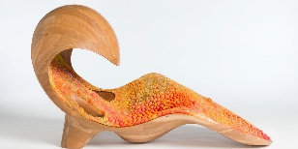
Design styles and movements.
- Modernism, e.g. Bauhaus
- Post modernism, e.g. Memphis.
Designers

- Neri Oxman - Design, biology, computing, and materials engineering
- David Adjaye – British Architect
- Yinka Ilori – Designer Collective
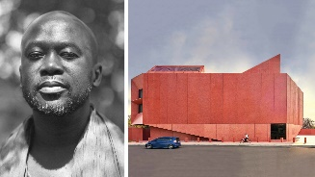
- Elsie Owusu – British Architect
- Karim Rashid – Industrial Designer
- Kusheda Mensah – Furniture Designer
- Aljoud Lootah – Multidisciplinary Designer
- James Dyson – Product Designer

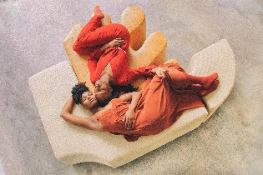
- Dieter Rams – Industrial Designer

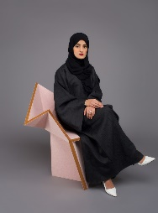

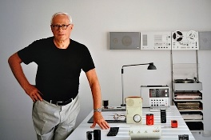


2. Technical Principals task

50% of the course is tested through two written exams. The Technical Principals paper will test a broad range of technical principals building on existing knowledge from the GCSE in Design and Technology.

It is recommended that you purchase the following revision guide to help support your start onto the course. We recommend the following revision book.

Materials are a big part of the theory exam where you must gain a wider understanding of where materials are from, what their properties are and where they are used and, the more we understand materials and how they behave the more creative we can be when it comes to designing products / prototypes. To give you a flavour of what the type of knowledge you will need please complete the following task.

Polymers Research Revision Resource.
Students can present digitally on PowerPoint /Canva / or in sketchbook

- Investigate the following classification of polymers.

  - sheet
  - film
  - granules
  - rod and other extruded forms
  - foam
  - powder

- Include a range of examples for each classification
- Include the source of the fibre
- List the properties and performance characteristics of each polymer stock form - give advantages and disadvantages of each.
- Include a range of end uses for each polymer – think about what products they can be made into and give reasons for their choice.

